Collision Rectangles and Action Points

Two other Invisible yet critically important features of gameplay that Spriter lets you edit on a per frame basic are Collision Rectangles and Action Points.

For any frame that you've created you can assign an unlimited number of Collision Rectangles. These are rectangles can have a name, width, height, and position of your choosing. You can even assign a numerical value to each of them!

These Collision Rectangles can be used within a game engine to decide when one thin is hitting or overlapping another, such as a fighter's fist hitting an opponents body. Most commonly Collision rectangles are used to either designate an ares that can be hit, or an area that can do the hitting... for instance in a fighting game, one or more rectangles would designate the players body which can be hit, but during attack animation frames, there would be additional collision rectangles which would represent the fist or foot that is doing the attacking.

Since you can assign numerical values to each Collision Rectangle independently, this is a wonderfully easy and visual way of controlling and tweaking the such things as the damage specific attacks will inflict on an opponent. (Another way would be with Character Variables.. please read that chapter as well)

In order to create a Collision Rectangle you:
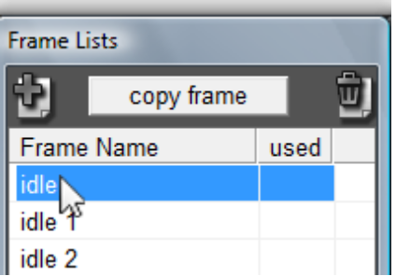
- Select the frame you want to add a collision rectangle to in the “Frame List” in the “Frame Lists ” window. NOT in the “Characters and Animations” window.

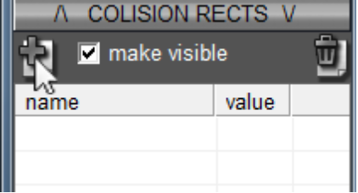
- Click on the “Create Collision Rectangle” button just above the “Collision Rectangle” list in the “Frame Lists” window. Also, make sure the check box labeled “make visible” just to the right of the “Create Collision Rectangle” button is checked so you'll be able to see the Collision Rectangles that you'll be creating.

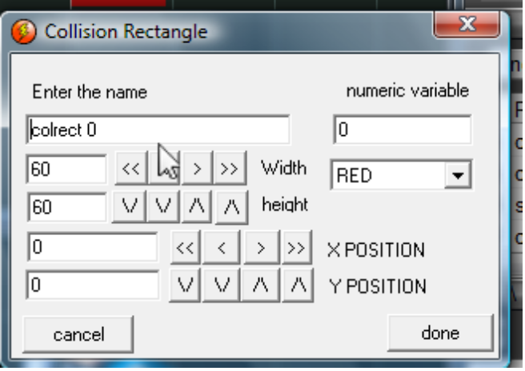
- 3)Use the dialogue that appears to control the Name, Width, Height, Position, Color, and Numerical Value of thee Collision Rectangle and click done when finished.

NOTE: Setting the colors of the Collision Rectangles in a manner to color code “types” can be very useful to stay organized... like making all “hittable” rectangles green and all “attacking” rectangles red for example.

To edit a Collision Rectangle that you've already created you have two options:

a) Simply double click on the name of the Collision Rectangle that you wish to edit in the “Collision Rectangle” list in the “Frame List” window. This will bring back up the original dialogue for editing all of the Collision Rectangles attributes.

b) If you only need to tweak the width, height or position of a Collision Rectangle, you can actually do so with simple key presses within the “Frame Preview” window. To do so you:
- Make sure the one or more Collision Rectangles that you want to edit are selected in the “Collision Rectangles ” list in the “Frame Lists” window. The selected Collision Rectangles should be flashing in the “Frame Preview” window.
- Click on the “Frame Preview” window and use the W,S,A or D keys to move the Collision Rectangles and hold “SHIFT” while pressing the W,S,A or D keys to alter its width or height!

Action Points have a different purpose:

Action points are a wonderfully easy and visual way to designate exact coordinates on a per frame basis where you might want something to spawn from (like a bullet or magic missile) or where you might want something attached to (like a gun, carried object, or special effect like fire on the head)

Spriter lets you create, position and name an unlimited number of action points per frame. Also, for the sake of staying organized visually you can choose from three different looks for each action point.

To Create an action point in a frame you:
- Select the frame you'd like to edit in the “Frame List” in the “Frame Lists” window.

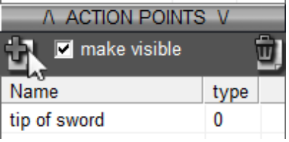
- Click on the “Create Action Point” button just above the “Action Point ” list in the “Frame Lists” window. Please also make sure the check box labeled “make visible” just to the right of the “Create Action Point” button is checked so you can see the Action Points you'll be creating.

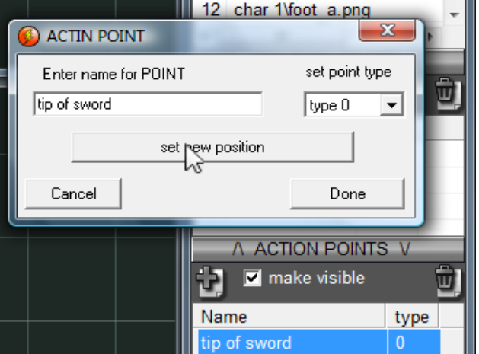
- Use the dialogue that appears to choose the name, appearance and position of the new Action Point. Click “Done” once you're finished.

To edit an Action Point that you've already created you have two options:

a) Simply double click on the name of the Action Point that you wish to edit in the “Action Point” list in the “Frame Lists” window and use the dialogue that appears to edit any of its attributes.
b) If you only need to tweak the position of an Action Point, you can actually do so with simple key presses within the “Frame Preview” window. To do so you:
- Make sure the one or more of the Action Points that you want to edit are selected in the “Action Point ” list in the “Frame Lists” window. The selected Action Points should be flashing in the “Frame Preview” window.
- Click on the “Frame Preview” window and use the W,S,A or D keys to move the Action Points.

One final note about editing Collision Rectangles and Action Points: There's actually a secret way to select them directly in the “Frame Edit” window when you want to move them around. Simply hold the “Ctrl” key while left clicking on them in the “Frame Preview” window!

